- In this Research Briefing, we answer questions that we received during our Global Economic Outlook Conference in London last week. Among the UK-centric topics were questions on policy, data problems, and sources of upside risk to our forecasts.

Q1: What policies in the UK are restrictive?
Though rate cuts by the Bank of England have been transmitted fairly quickly to the corporate sector, we still see monetary policy as being restrictive because of the lagged impact of prior tightening on the cost of servicing the stock of household mortgages. The average interest rate on outstanding mortgages continues to creep upwards because the impact of cheaper variable-rate mortgages is more than offset by the effect of borrowers refinancing expiring fixed-rate deals – mortgagors refinancing loans taken out before mid-2022 are typically seeing their interest rates increasing by 200bps-250bps. We forecast the average interest rate to not fall until H2 2027.
Tighter fiscal policy is more important. In the current fiscal year, 2025-2026, we estimate that fiscal policy will exert a drag of 0.6% of potential GDP (Chart 1). There will be similar drags over the two following fiscal years, with all the tightening coming via higher taxation. In this environment, it looks likely that UK GDP growth will remain sluggish.
Chart 1: Fiscal policy will be tightened significantly over the next four fiscal years
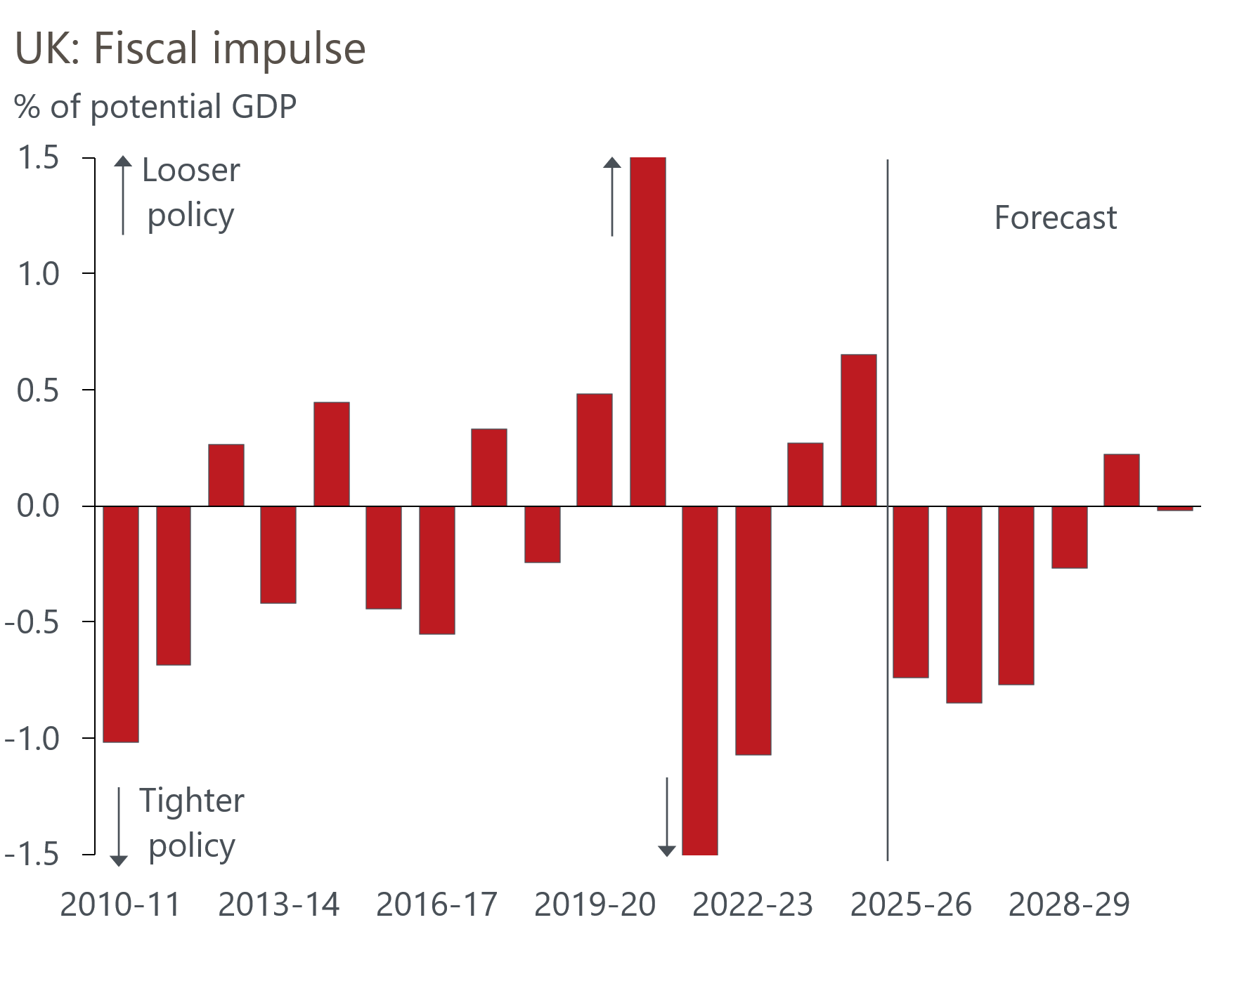
Sources: Oxford Economics, Haver Analytics

Q2: Over what period do you assess whether a fiscal adjustment is a success?
Normally, we like the definition used in a 2012 paper by Alesina and Ardagna, which defines a successful fiscal adjustment as the debt-to-GDP ratio being lower two years after the adjustment ended, compared to its level in the final year of the adjustment. The consolidations analysed in that study are typically much shorter than the current UK one. Successive governments have chosen to extend the UK consolidation plan to the extent that even based on the Office for Budget Responsibility's optimistic forecasts, there will be no meaningful fall in government debt as a share of GDP in a decade after the pandemic. So, based on the Alesina and Ardagna definition, we can't judge success or failure until well into the 2030s.

Because it'll take so long to achieve any sort of reduction in debt, it's hard to subjectively judge the plans of successive UK governments as anything other than a failure.
As we reported in a note published last year, Alesina and Ardagna's work suggests the shape of consolidation chosen by the current government increases the chances of failure. Their study found that successful adjustments had around a 70% share of spending cuts in the total adjustment, while unsuccessful adjustments had a share of just 45% (Chart 2). Similarly, the study of more than 300 episodes by Tsibouris et al. found that sustained adjustments had a 75-25 ratio between spending cuts and revenue rises, while reversed adjustments had a 50-50 share. With the UK's adjustment entirely based on tax rises, the chances of success are low.
Chart 2: Revenue-based adjustments tend to be less successful
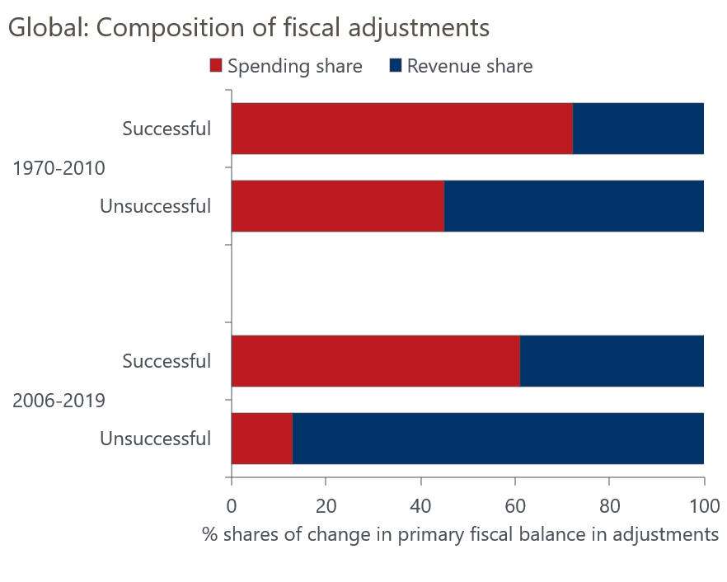
Sources: Oxford Economics, Alesina & Ardagna (2012)

Q3: How do you see the UK-EU relationship developing?
US foreign policy has become unpredictable, leaving the UK government to try to build bridges with the European Union and pursue common goals in areas such as defence.
The UK has also intimated that it would like to discuss a closer trading relationship with the EU. But for the foreseeable future, any deals are likely to be relatively small, such as a youth mobility scheme and a veterinary deal to try and reduce regulatory checks on agricultural and food products. A more meaningful reduction in trade barriers would only be possible via membership of the single market or forming a customs union with the EU. Neither option looks realistic anytime soon, particularly with the unpopularity of the government and the strong resistance to a closer UK-EU relationship among right-wing opposition parties.

Q4: What things could be done to improve the UK's economic situation?
In the near term, a more credible approach to fiscal policy would bolster financial market confidence and improve the chances that the consolidation is successful. Such a plan would involve reducing the reliance on tax rises and showing greater spending restraint, with a push to improve public-sector productivity being crucial to lowering spending.
The government came to power promising a focus on improving economic growth. But we've been underwhelmed by the policies announced so far, and would advocate a renewed focus on this issue. We've previously laid out our plan for growth and highlight two of our recommendations as having the potential to improve the situation.
First, we think there should be more support for investment in intangible assets, such as software, databases, and research. Investment in intangibles is a key driver of productivity growth but the UK lags well behind the global leaders, the US and Japan. Financing issues are a key constraint, and an obvious solution would be to extend the UK's generous capital allowances for plant and machinery to include intangibles, reducing the upfront cost of investment. So far, the UK has been left behind in the race to benefit from advances in AI, but encouraging stronger investment could help make up for lost time.
Second, reforms to boost labour participation are needed. Options include:
- Additional support for childcare costs, which are quite high by European standards. This would help to lift female participation rates, which for the 25-59 age groups in the UK are currently around 5ppts lower than those of countries, like Austria, Denmark, and France, that have much lower childcare costs.
- More emphasis on getting people, where possible, off incapacity benefits and into work. Levels of inactivity due to illness or incapacity are far higher in the UK than elsewhere in Europe. Inflows into incapacity benefits have been high and the number coming off these benefits and back into work are low. Solutions should focus on ensuring that those with long-term conditions can remain in work and on improving pathways into work for those on benefits.
- More support for older workers. With an ageing population, the extent to which older people stay in the workforce is a key driver of labour supply. The over-65 employment rate is much lower in the UK than in most other advanced economies. A package of measures to incentivise older workers to remain in the labour force would help in this respect, with measures undertaken by New Zealand a good template to follow.

Q5: Would it help the government in the UK to go back to quarterly GDP?
Monthly GDP data is extremely volatile. The Office for National Statistics recently acknowledged this can lead to users misinterpreting the key messages, and its solution has been to prioritise the three-months-on-three-months change in its commentary.
Our bigger concern with the monthly GDP series remains the question of residual seasonality. Since the pandemic, there's been a clear pattern where years get off to a strong start but momentum fades in Q2 and Q3 before another rally appears towards the end of the year. Data for the first 11 months of 2025 follows that pattern closely (Chart 3). So far, the ONS has denied there's a problem, but this is happening so regularly that it's increasingly hard to argue it's a coincidence.
Chart 3: We think monthly GDP data shows evidence of residual seasonality
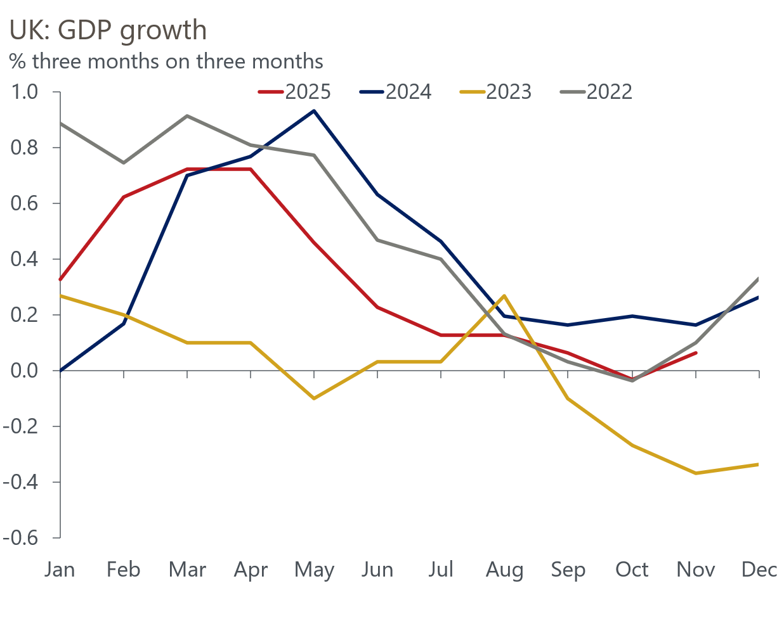
Source: Haver Analytics

Q6: Are there any notable upside risks?
Our baseline forecast shows a continuation of the recent sluggish UK growth rates, with tight policy settings weighing on activity in the near term, and a combination of an ageing population and weak productivity growth undermining longer-term prospects. We view the risks to both parts of the forecast as being skewed to the downside.
In the near term, a potential upside risk is a quicker normalisation of household saving rates. Households have been saving more than normal in recent years and showing relatively weak demand for credit. Our baseline forecast assumes this behaviour normalises very slowly, but a more rapid return to lower savings rates could yield a stronger boost to growth.
A continuation of the global AI boom is another upside risk. Higher tech investment and a further strengthening in tech stocks would primarily benefit the US. But we would also expect to see positive spillovers to other countries via stronger US demand, wealth effects, and faster AI adoption boosting productivity growth.
Looking further out, our Megatrends Scenarios identify a technological revolution scenario as the key upside risk. In this scenario, trade barriers are eased over the next decade, fostered by greater cooperation. Productivity growth strengthens amid a more stable business environment, stronger technological progress, and higher fertility rates, compared to our baseline. A virtuous circle of economic growth drives rising living standards and improved financial stability. Nominal and real interest rates would also rise in this scenario.

